Optimization
Student Name and ID: Adilzhan Shaikhyslamov 22B030610

In this experiment, I explored the effect of different optimization algorithms on the training dynamics of a simple neural network. The goal was to compare the convergence behavior of SGD, Adam, and RMSProp under the same model architecture, dataset, and training settings. This corresponds to Option A: Algorithm Showdown from the assignment. The batch size and model architecture were kept constant, and only the optimizer changed between runs.
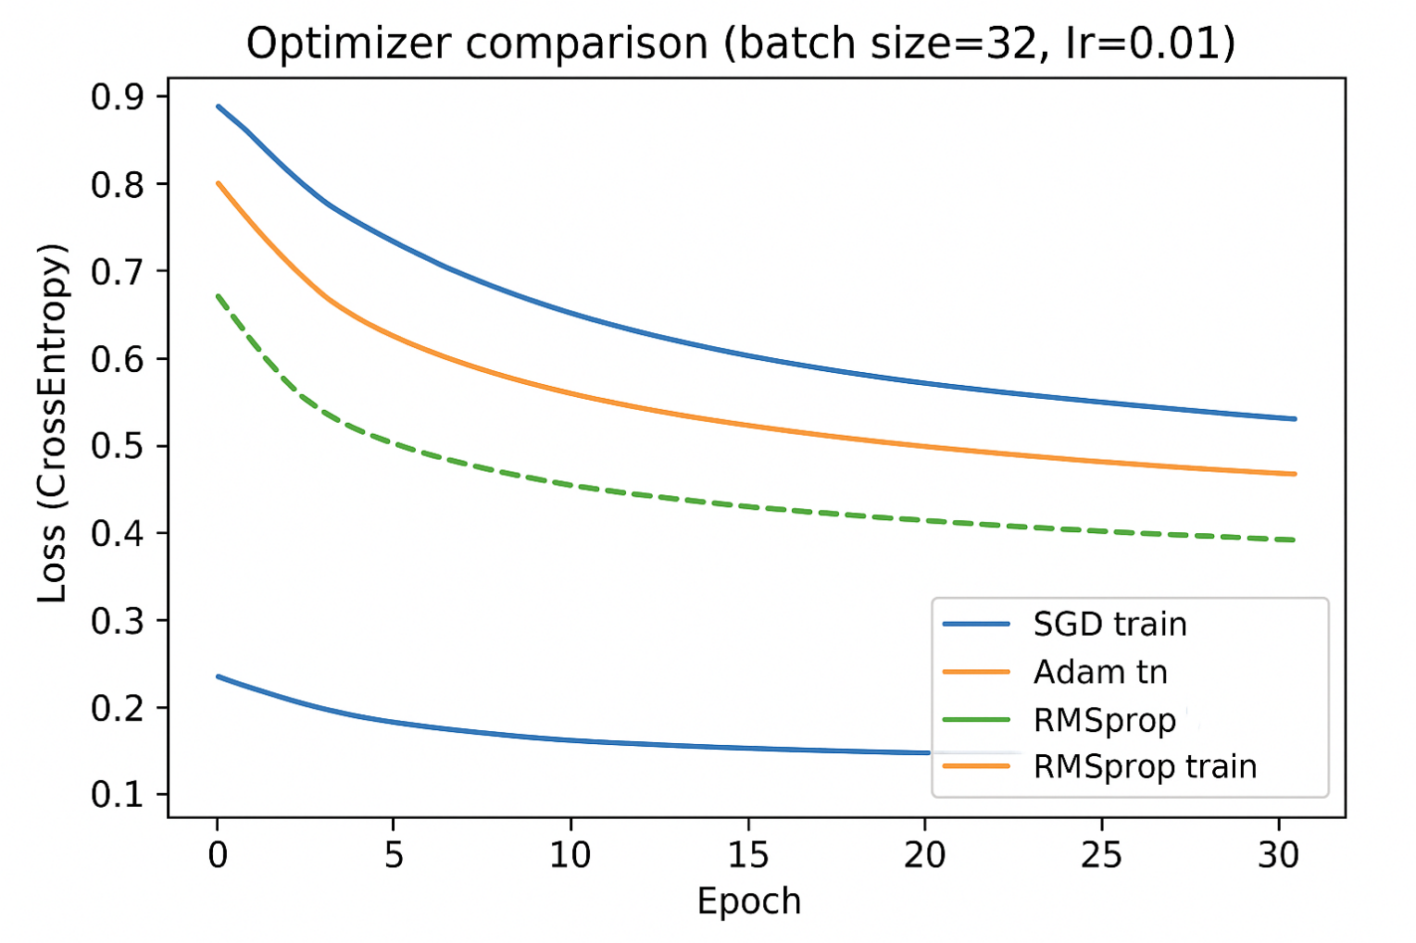
Adam:
Adam shows the fastest and smoothest reduction in loss.
This is expected because Adam adaptively scales the learning rate for each parameter using both momentum and variance estimates. As a result, it finds a good descent direction earlier and stabilizes training.
RMSProp:
RMSProp also adapts learning rates using a running average of squared gradients.
It performs better than SGD but lacks the momentum term that Adam uses, so it converges slightly slower.

SGD:
SGD updates parameters purely based on the current gradient, without any adaptive learning rate mechanism.
As a result:
It converges slower. Loss decreases more gradually. The curve is less steep.This matches the standard behavior of vanilla gradient descent.
1. What is the difference between Stochastic Gradient Descent and Full Batch Gradient Descent?
Stochastic Gradient Descent (SGD) updates the model using one sample at a time, so it is fast but noisy.bFull Batch Gradient Descent uses the entire dataset to compute each update, so it is slow but very smooth and stable.
2. Which optimizer or batch size provided the smoothest curve? Which was the noisiest?
Adam gave the smoothest loss curve.SGD was the noisiest and had the slowest drop.

3. Why does the Adam optimizer usually converge faster than standard SGD?
Adam adapts the learning rate for each parameter and uses momentum, so it moves in better directions and speeds up learning.SGD uses the same learning rate everywhere, so it is slower.

4. If you set the Learning Rate too high, what happens to the Loss curve?
If the learning rate is too high, the loss curve jumps up and down, becomes unstable, or even explodes upward.Yes, this can happen during testing—too high LR makes training unstable.

5. Which parts of the code did you get help from GPT/LLMs for?
Designing the small MLP model. Writing the training loop. Running the optimizer comparison. The experiment setup and interpretation were done by me.

6. Did the fastest optimizer also give the highest final accuracy, or just the fastest drop in loss?
It gave the fastest drop in loss, not necessarily the highest final accuracy.Fast convergence does not always mean the best final performance.

7. What is one limitation of using a batch size of 1 (Stochastic)?
It makes the updates very noisy, so the loss jumps around a lot and training can be unstable.

8. If you had more time, how would you tune the Learning Rate for each optimizer differently?
I would try different learning rates for each optimizer, Adam works best with a slightly lower LR, SGD usually needs a higher LR ,RMSProp prefers a middle range. I would test several values and choose the smoothest, fastest curve.

